**Assignment No:-18**

Name:-Suryawanshi Sangramsingh Sambhaji

Batch: - Delta - DCA (Java) 2024 Date:-28/5/2024

**12. Given a sorted array of n distinct integers where each integer is in the range from 0 to m-1 and m > n. Find the smallest number that is missing from the array.**

**Examples:**

**Input: {0, 1, 2, 6, 9}, n = 5, m = 10**

**Output: 3** 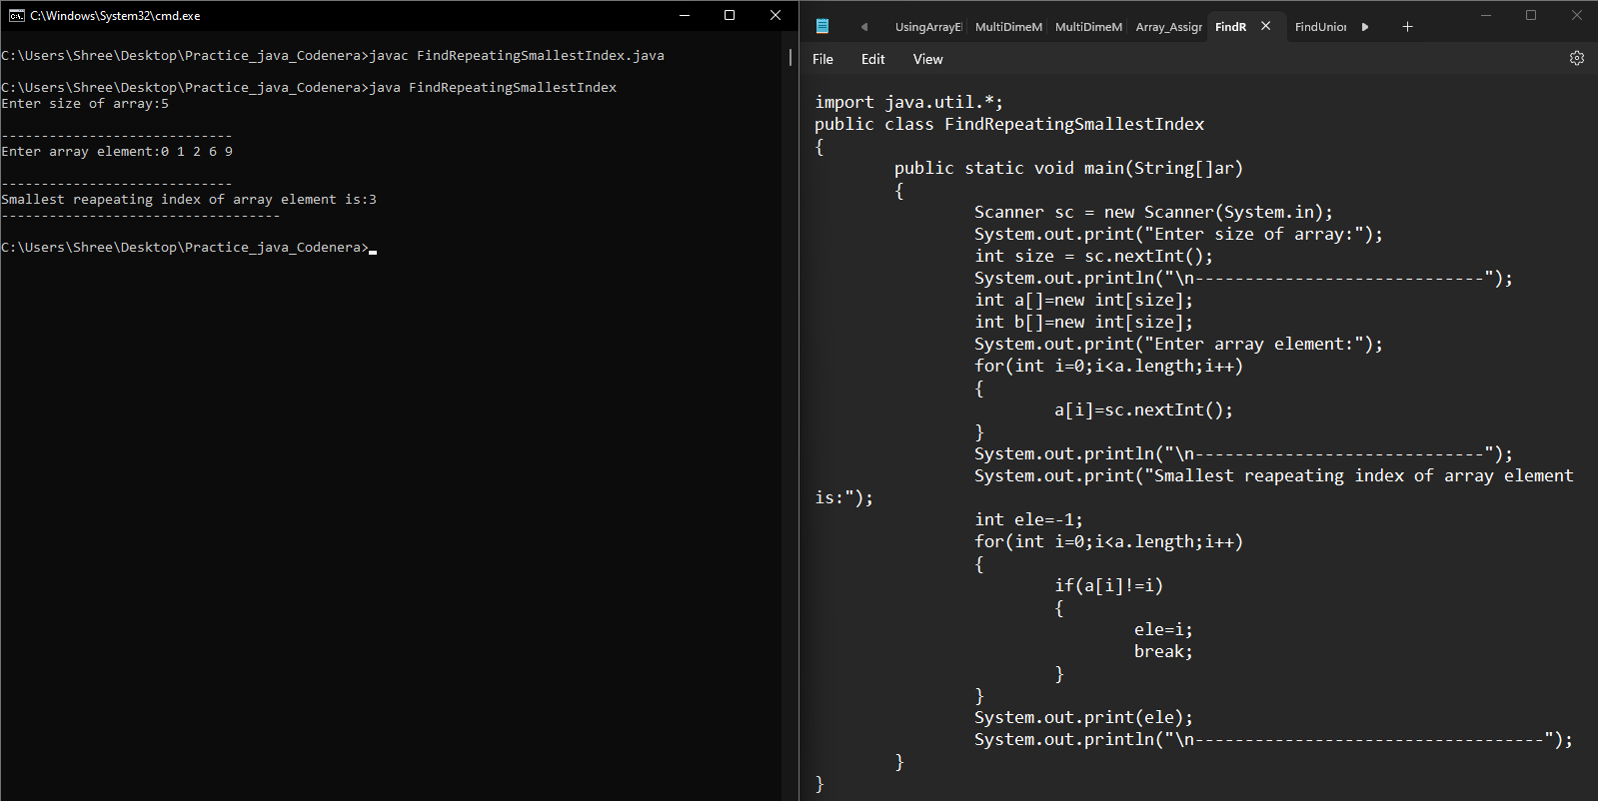

**1. Write a Java program to add two matrices of the same size.**

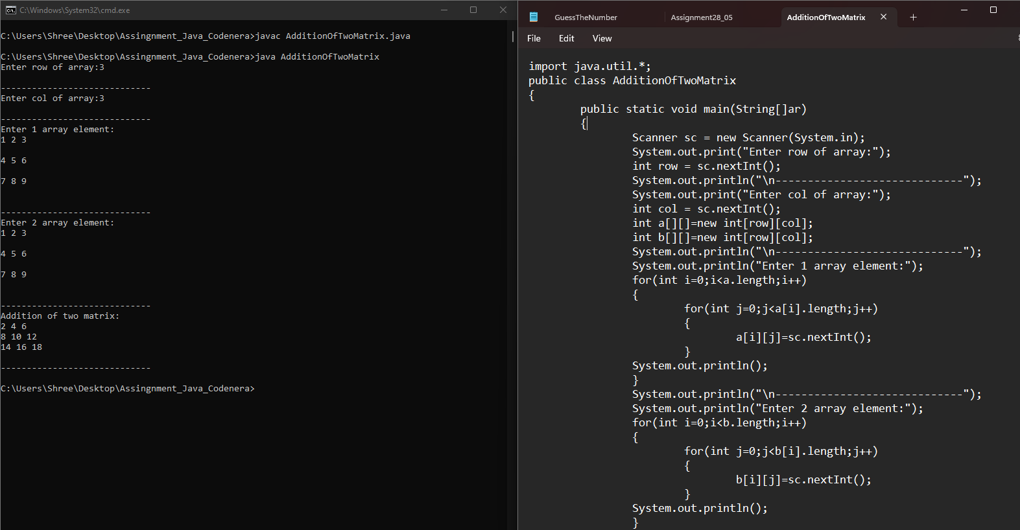 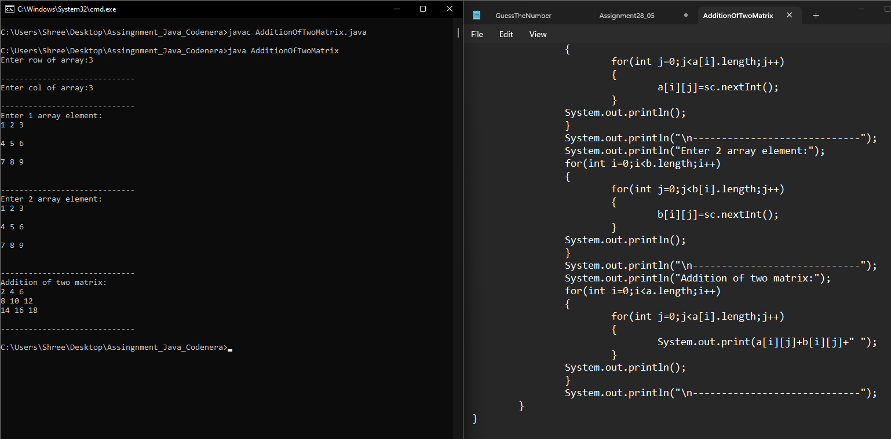

**2.** **Write a Java program to rotate a matrix by 90 degrees clockwise.** 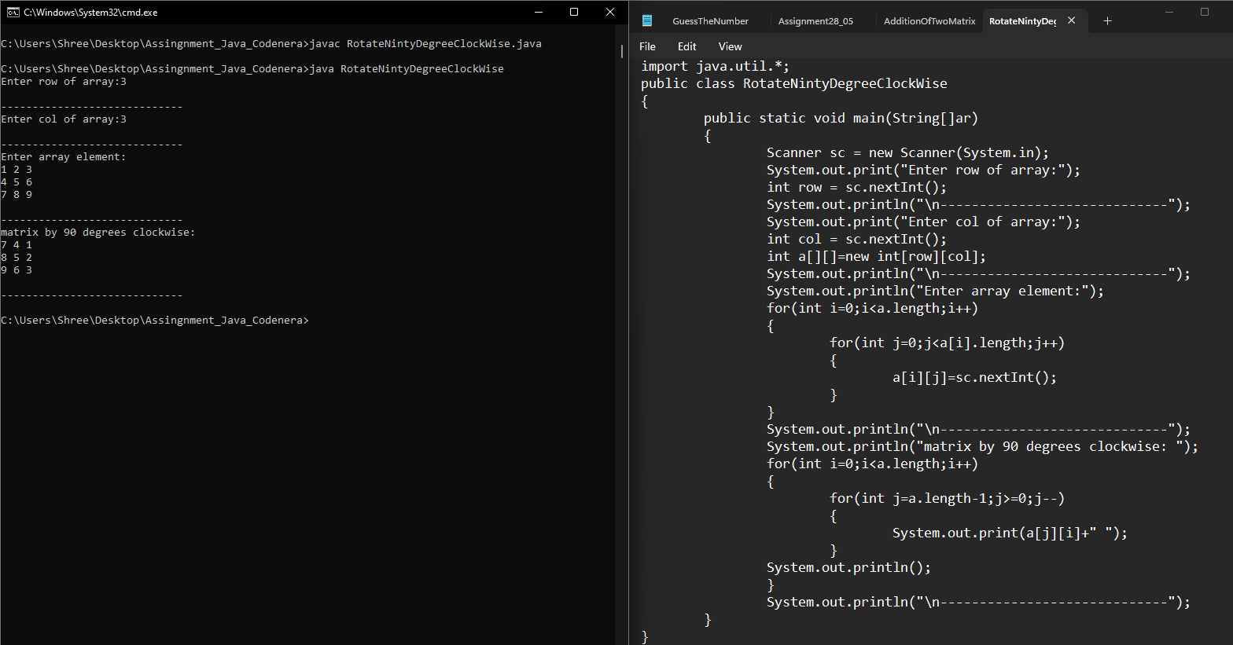

**3.** **Write a Java program to find the transpose of a matrix**

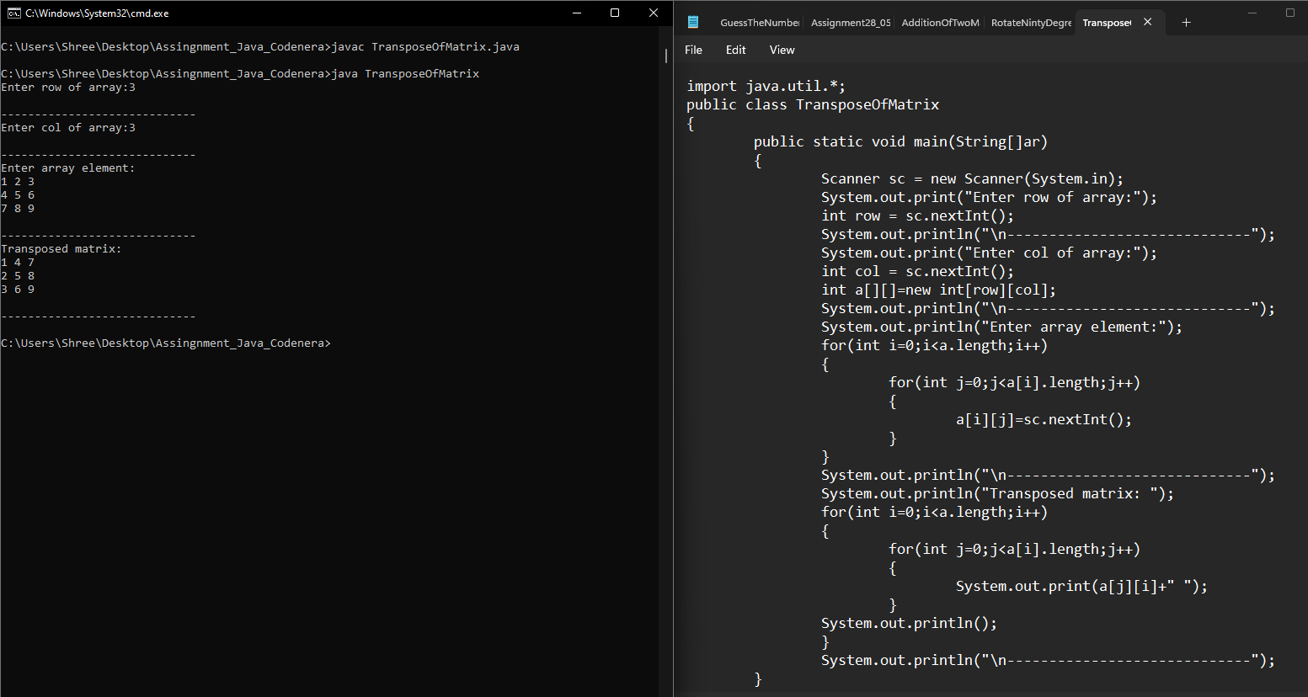

**4. Write a Java program to check if a matrix is symmetric.**

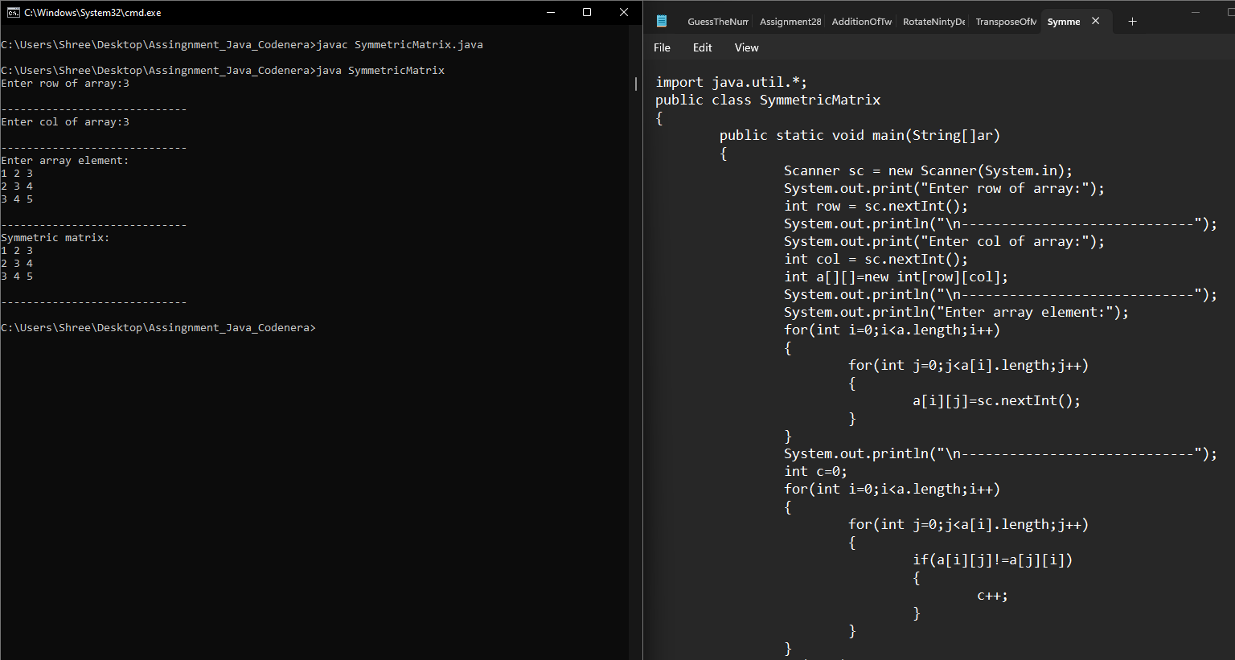

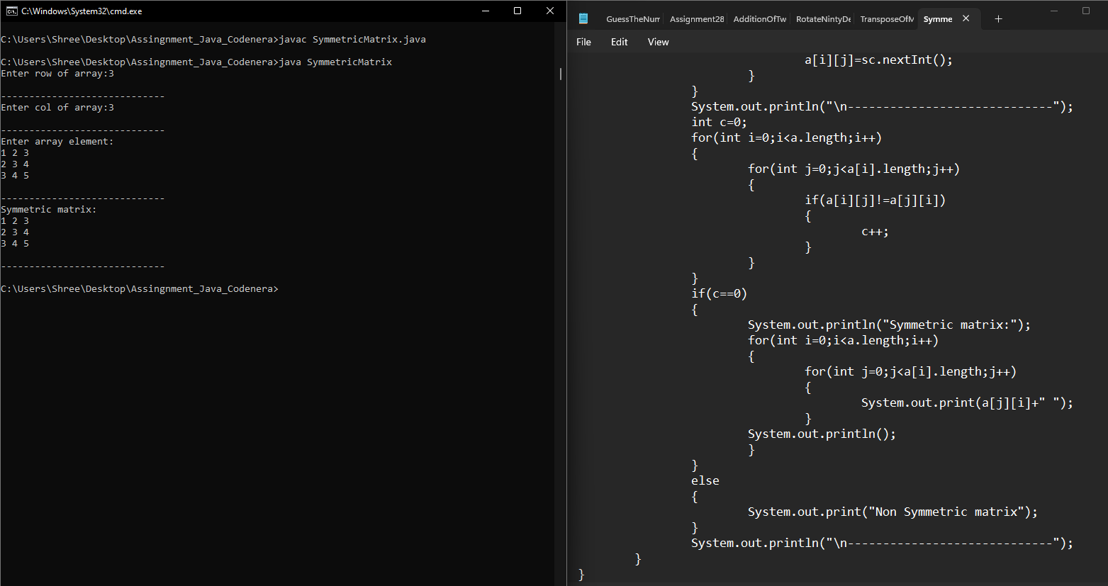

**5. Write a Java program to check if a matrix is diagonal.**

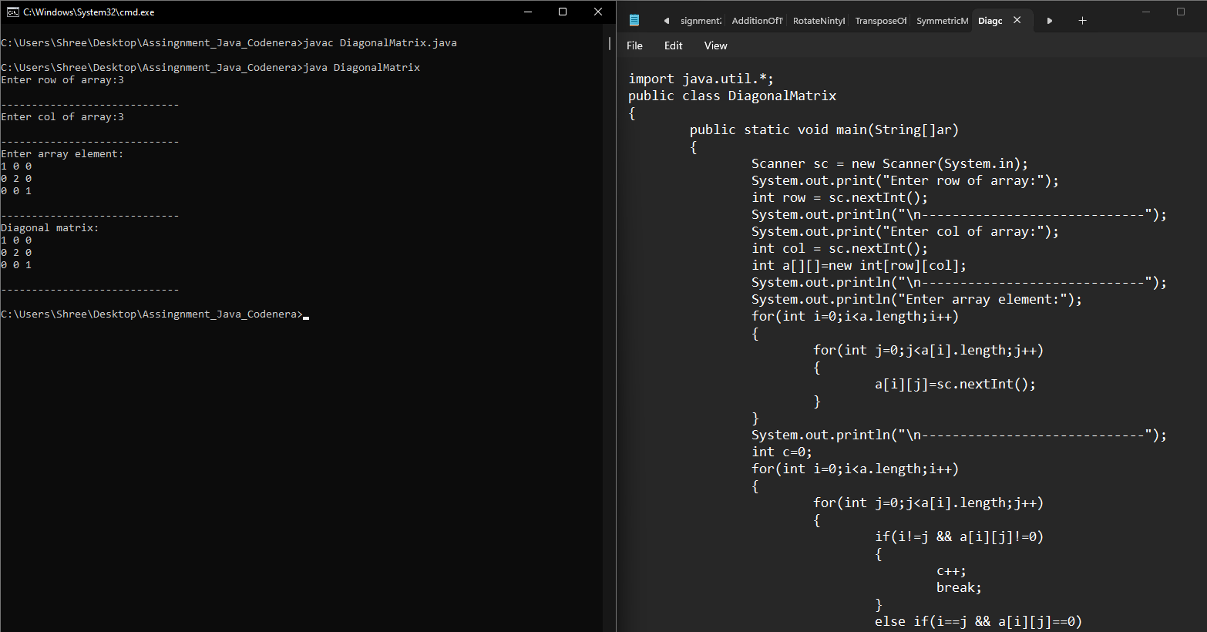 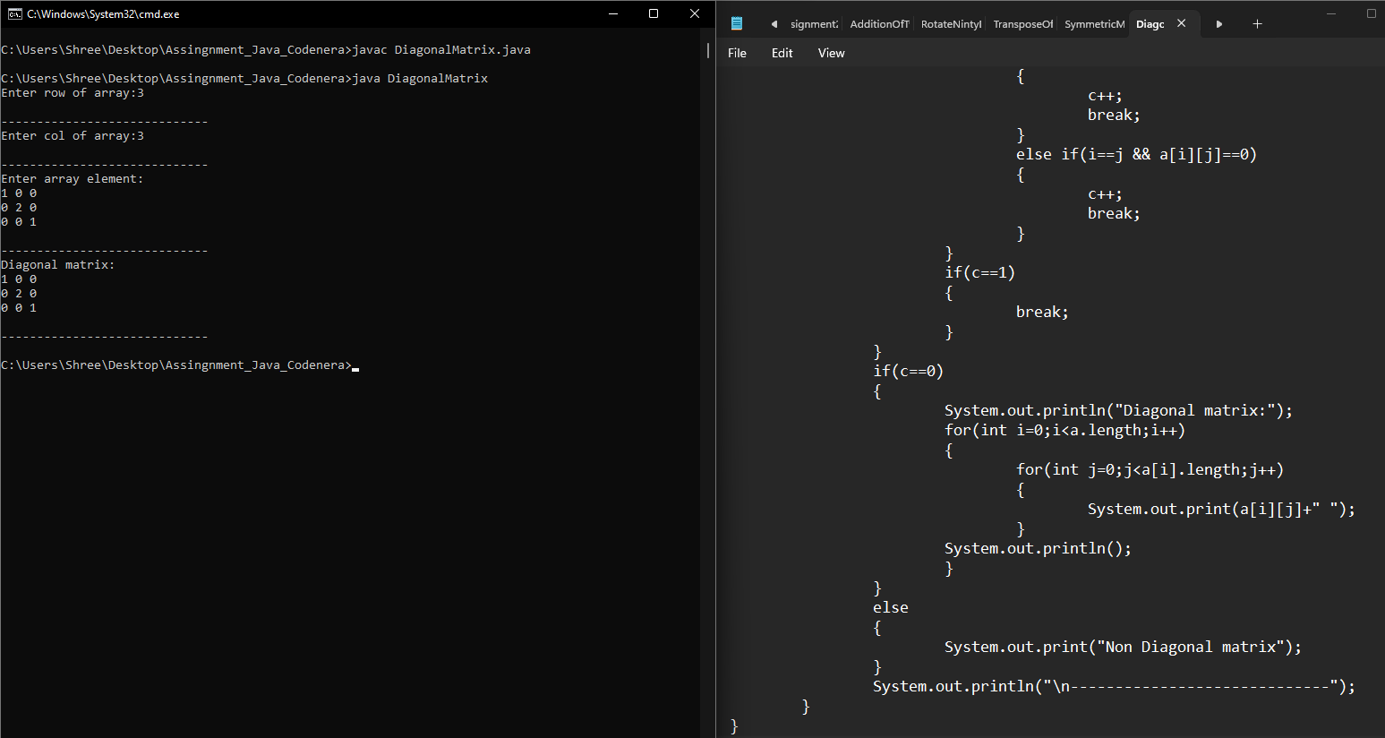

**6.** **Write a Java program to find the sum of the diagonal elements of a matrix.**

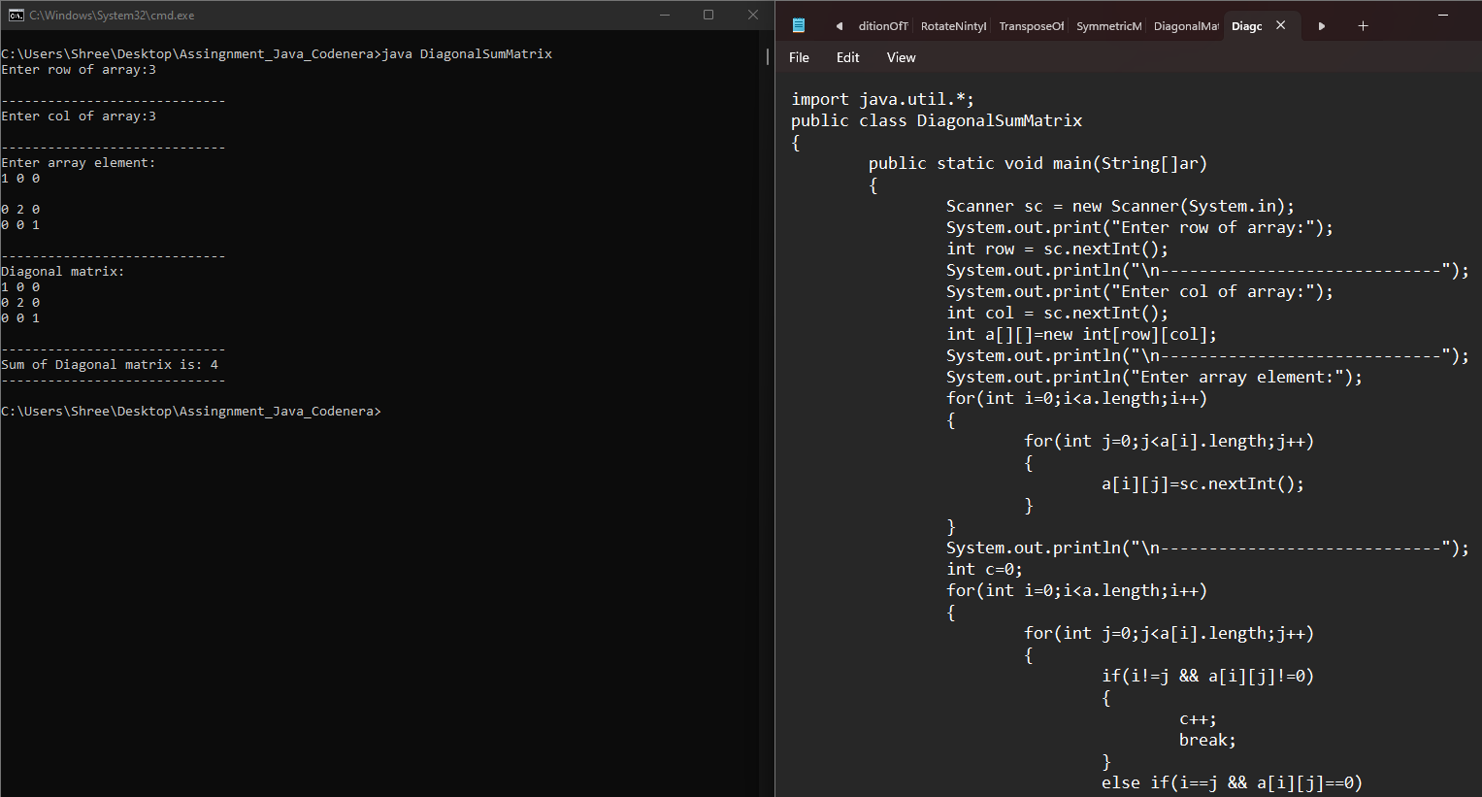 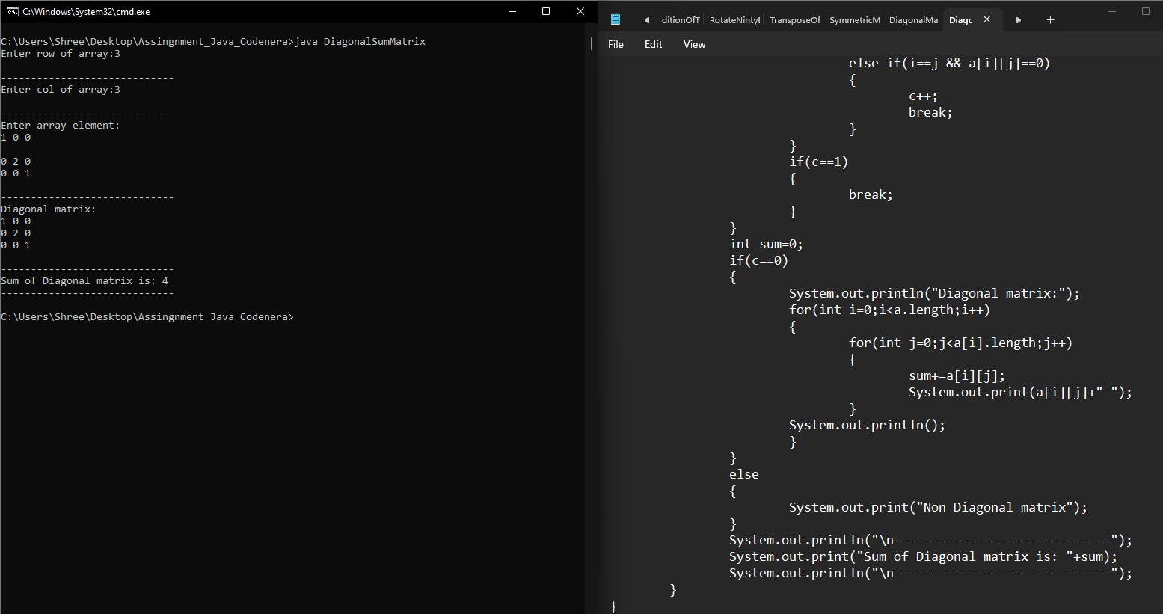

**7. Write a Java program to find the product of diagonal elements of a matrix.**

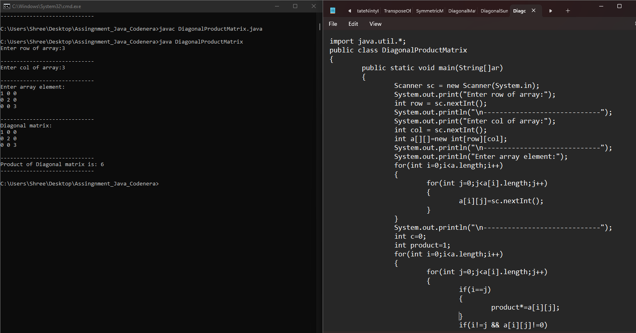 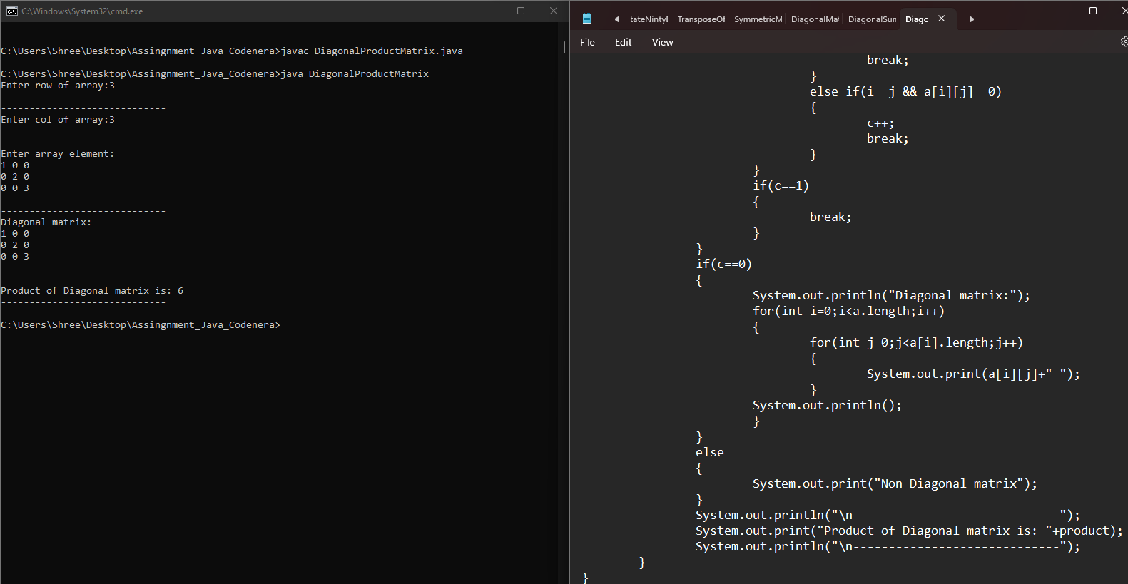

**8. Write a Java program to find the sum of each row and column of a matrix.**

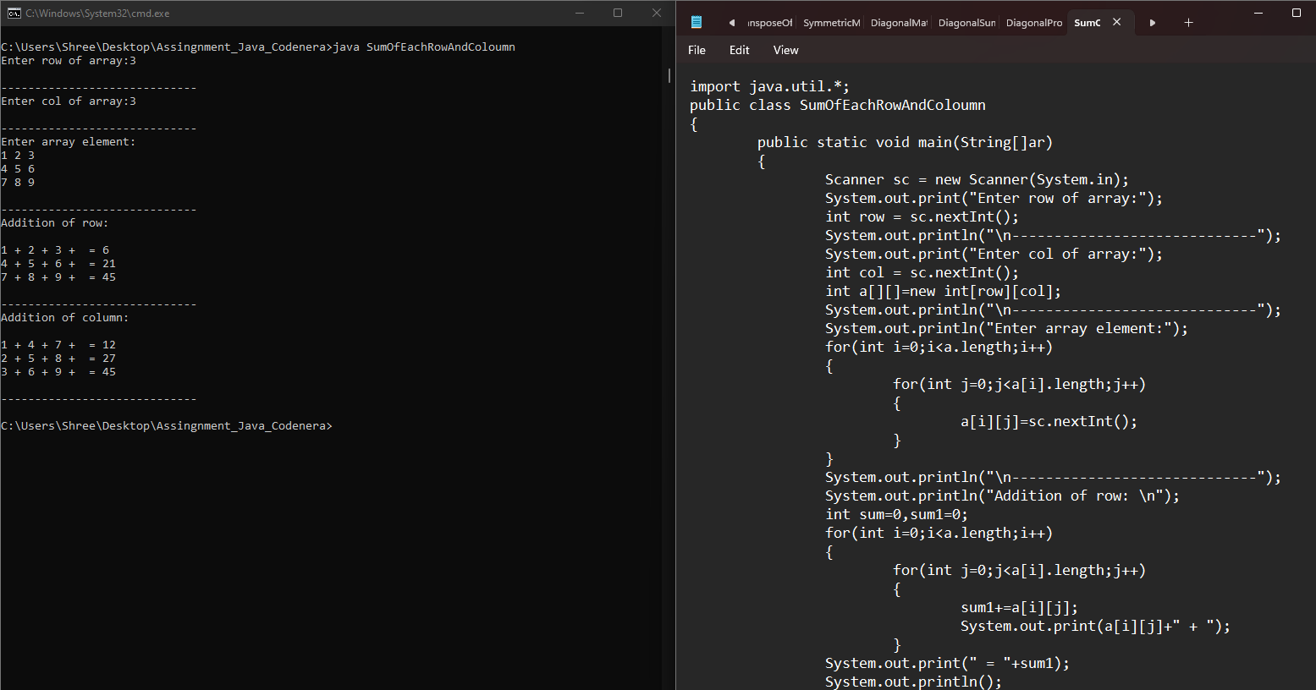 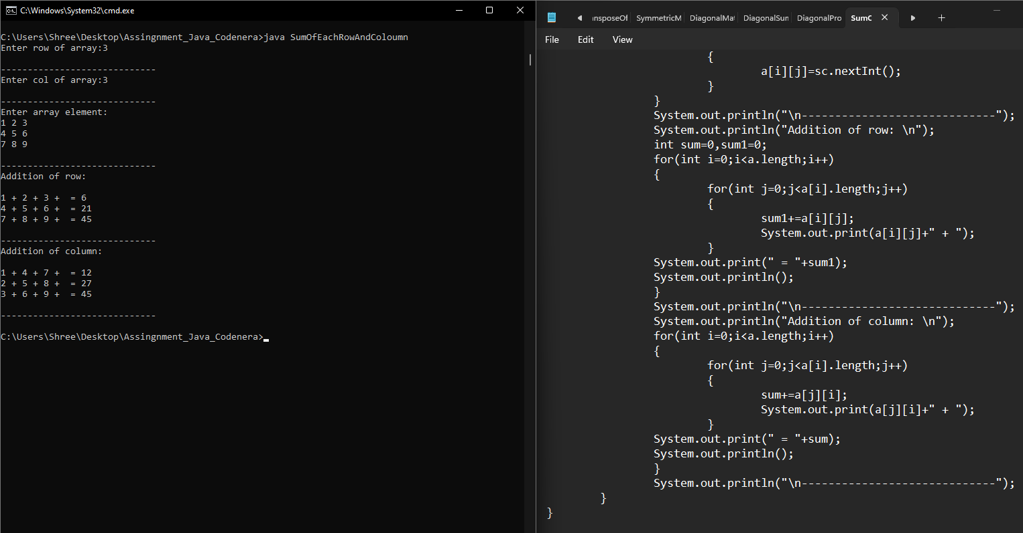

**9. Write a Java program to find the maximum element in a matrix.**

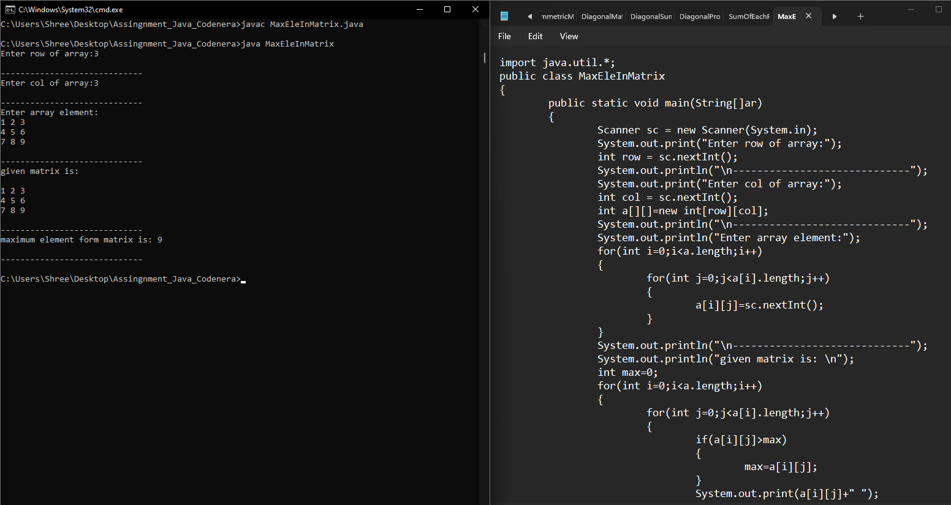 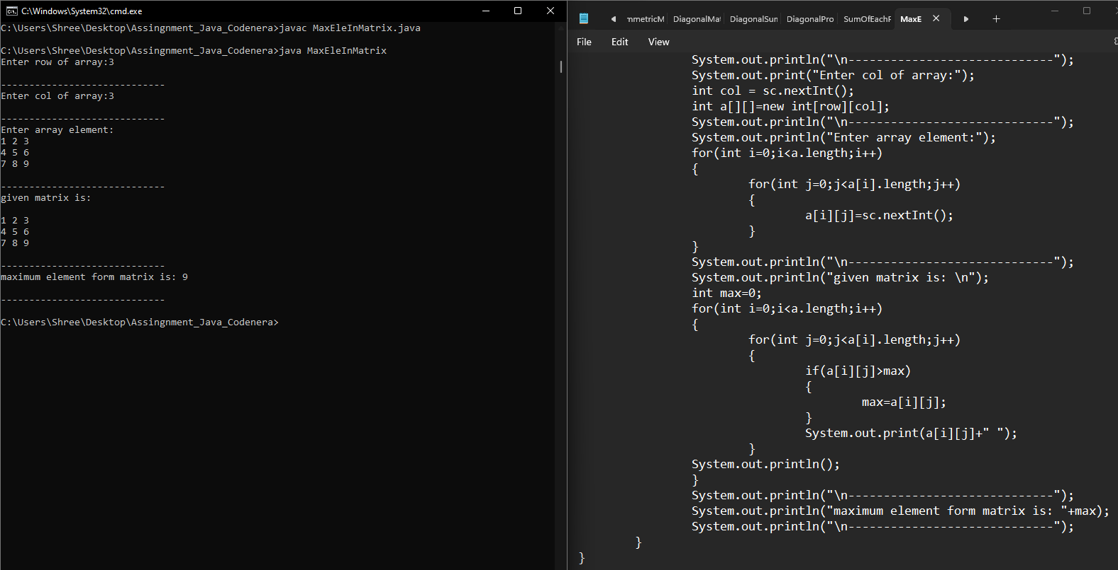

**10.** **Write a Java program to find the minimum element in a matrix**

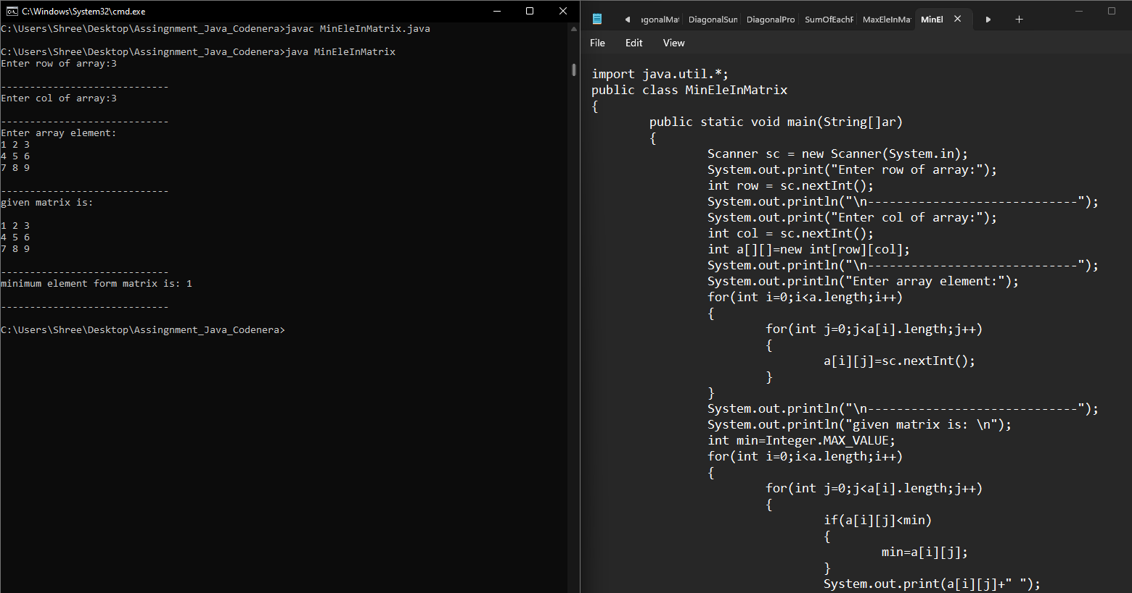 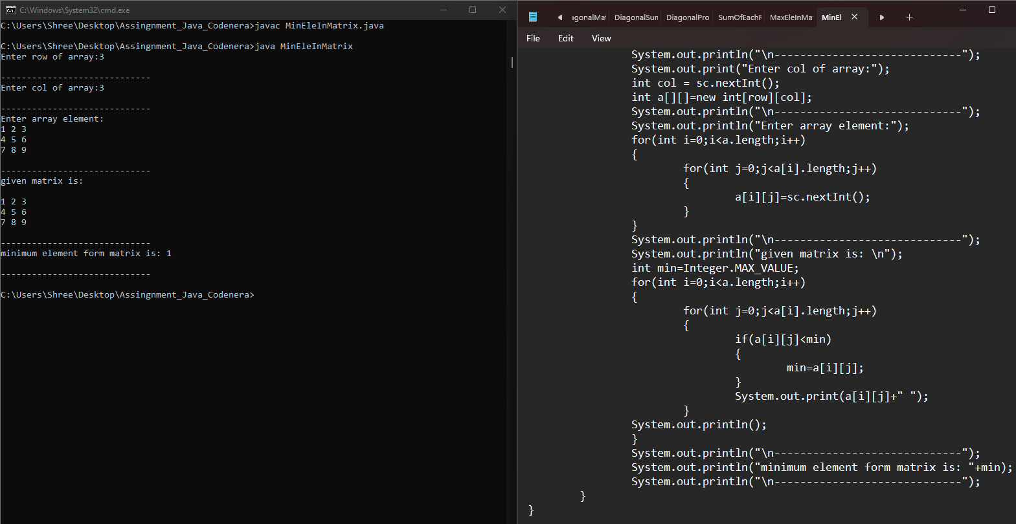

**11. Write a Java program to sort the elements of each row of a matrix.**

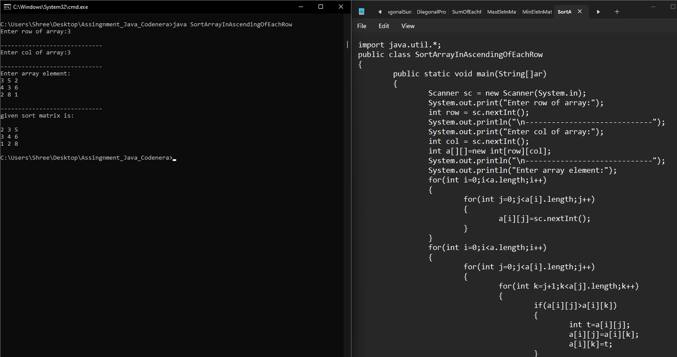 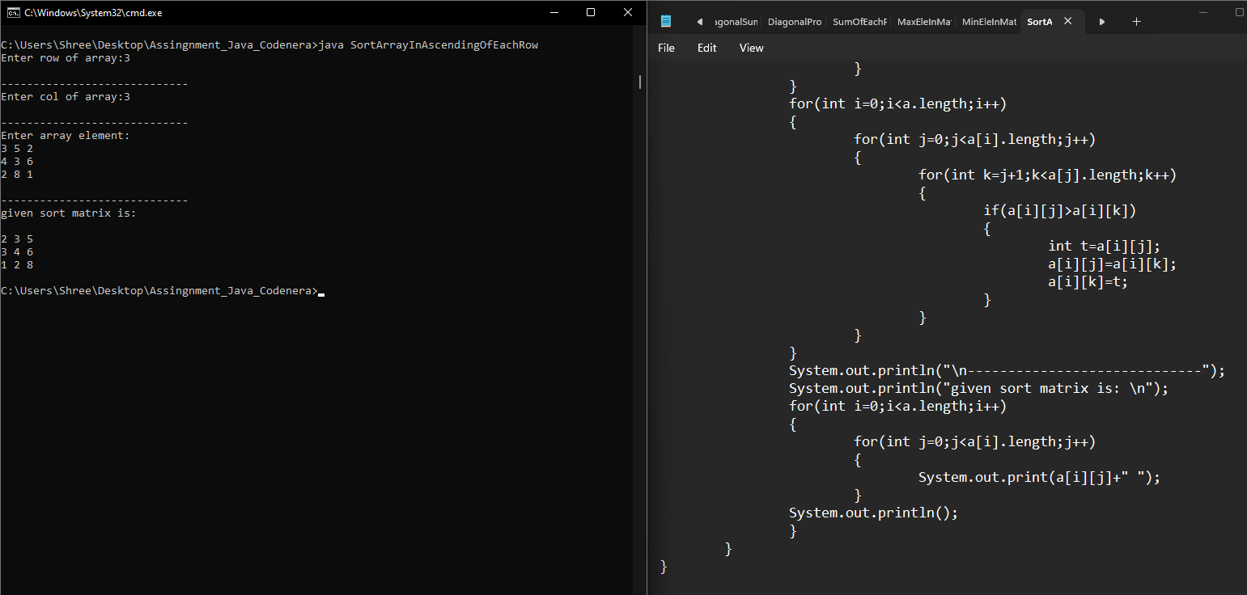

**12. Write a program enter an array and print the square of the element which is present at odd position.**

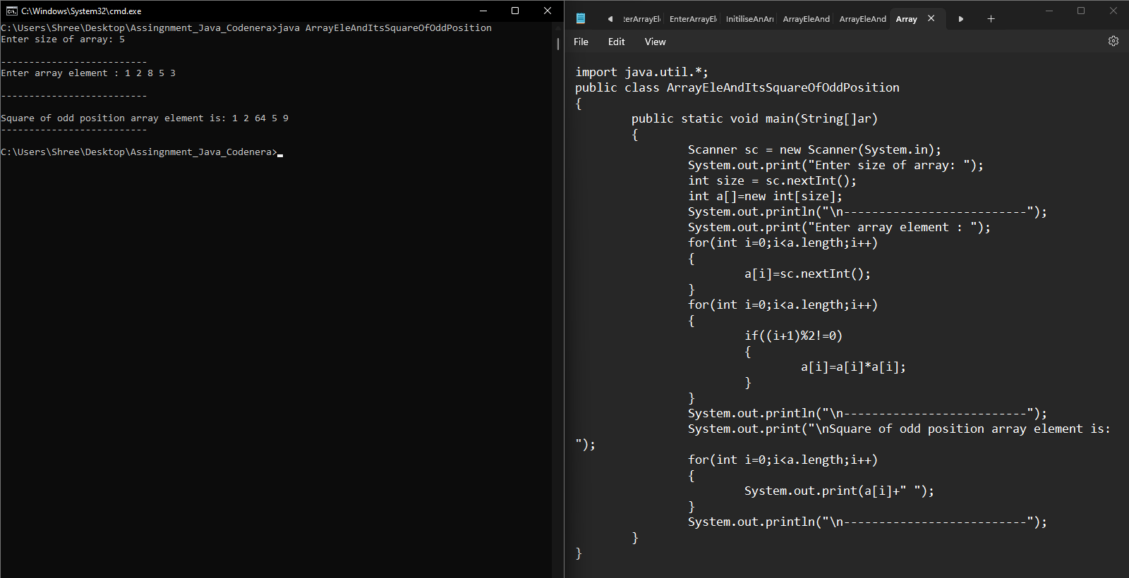

**1. Write a Java program to find maximum product of two integers in a given array of integers.**

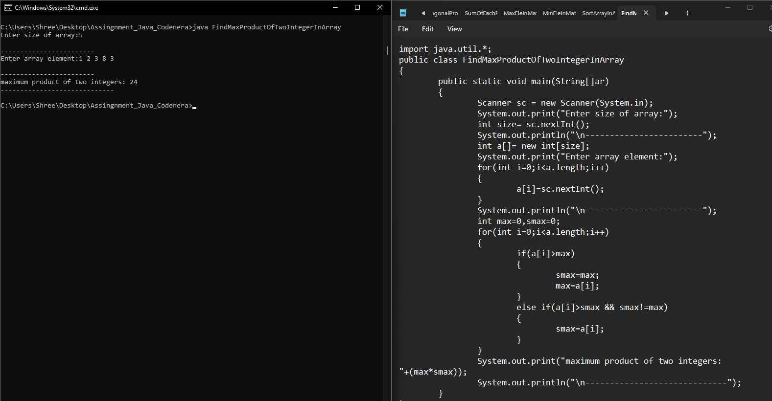

**2. Write a Java program to shuffle a given array of integers.**

**Example:**

**Input: nums = {1, 2, 3, 4, 5, 6}**

**Output: Shuffle Array: [4, 2, 6, 5, 1, 3]**

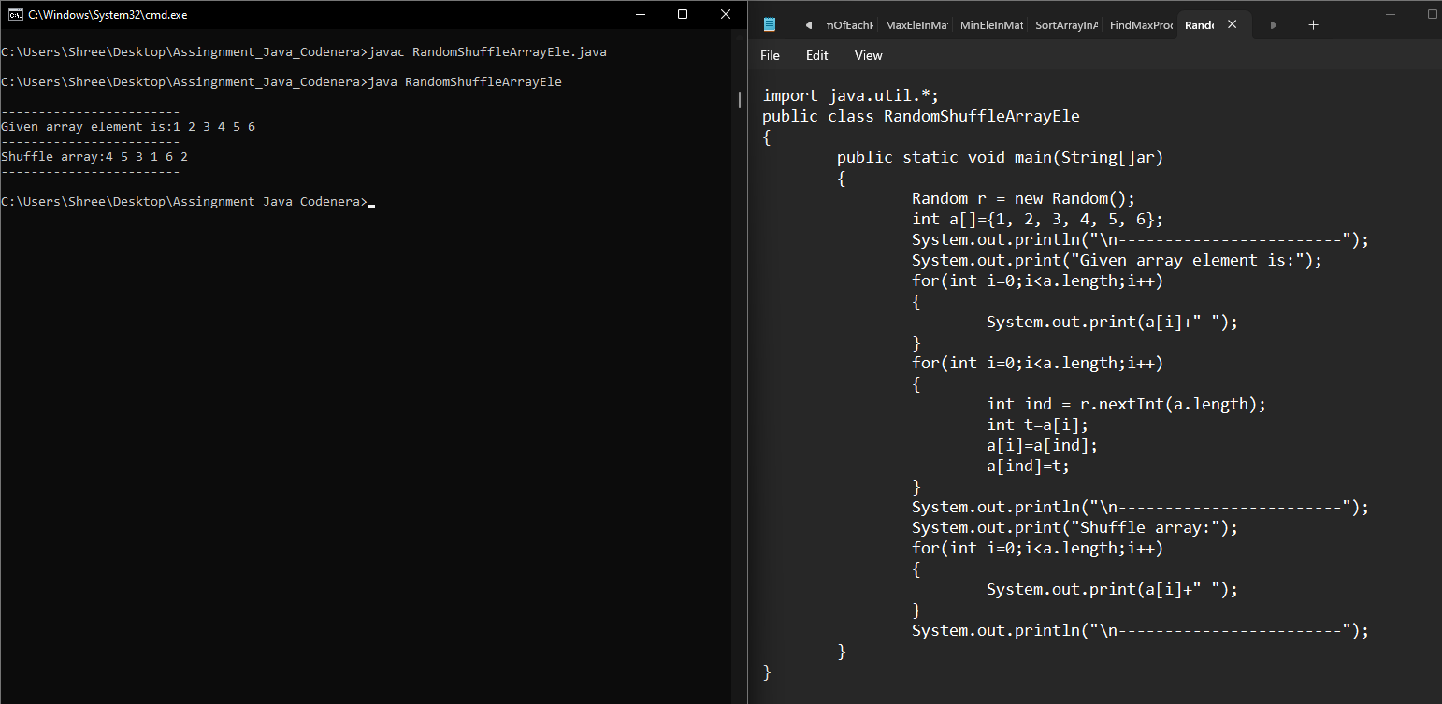

**3. Write a Java program to rearrange a given array of unique elements such that every second element of the array is greater than its left and right elements.**

**Example:**

**Input: nums= { 1, 2, 4, 9, 5, 3, 8, 7, 10, 12, 14 }**

**Output:Array with every second element is greater than its left and right elements:**

**[1, 4, 2, 9, 3, 8, 5, 10, 7, 14, 12]**

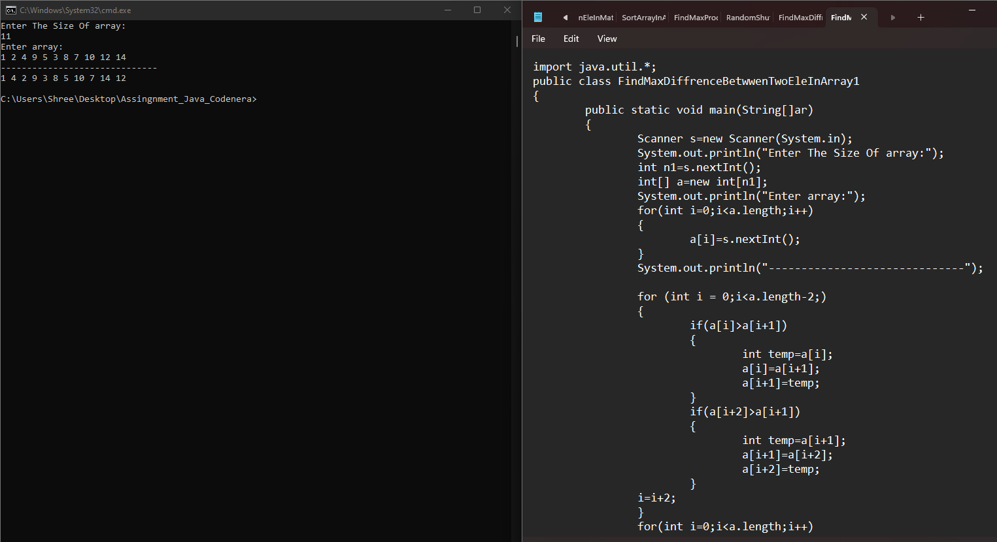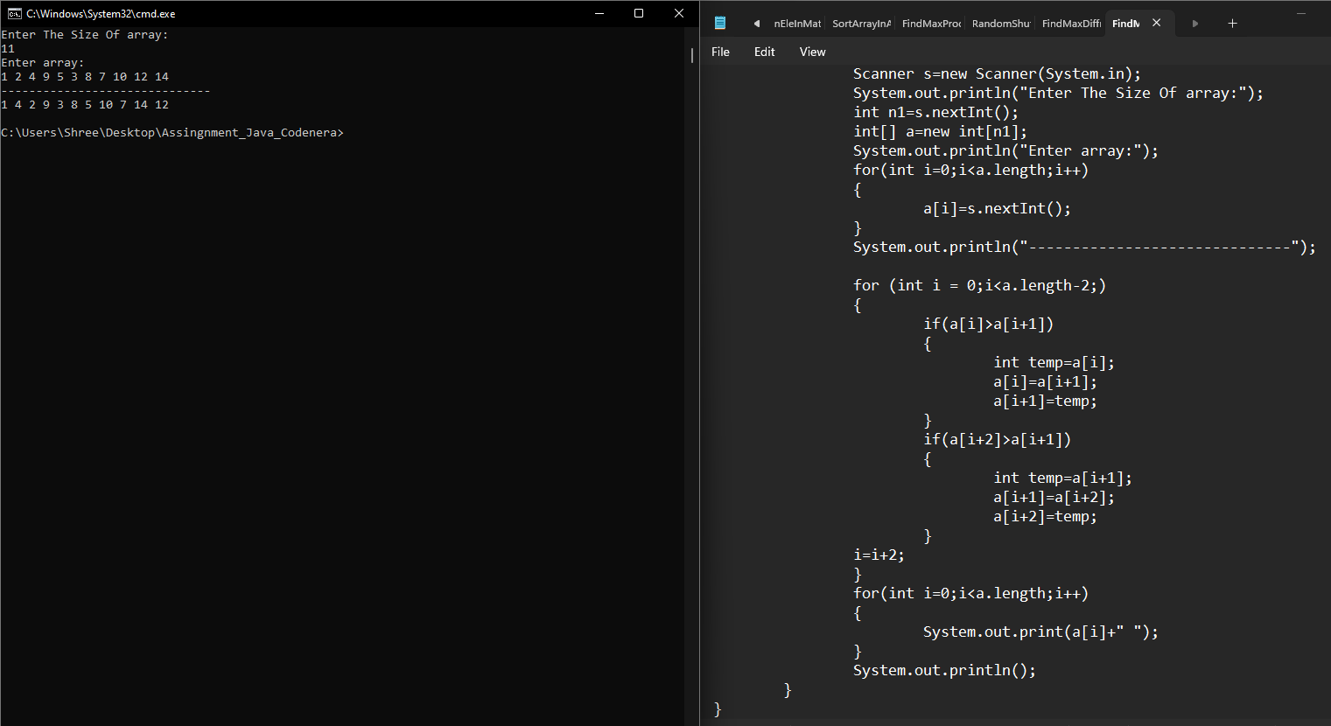

**4. Write a Java program to replace each element of the array with product of every other element in a given array of integers.**

**Example:**

**Input :nums1 = { 1, 2, 3, 4, 5, 6, 7}**

**Output: Array with product of every other element:[5040, 2520, 1680, 1260, 1008, 840, 720]**

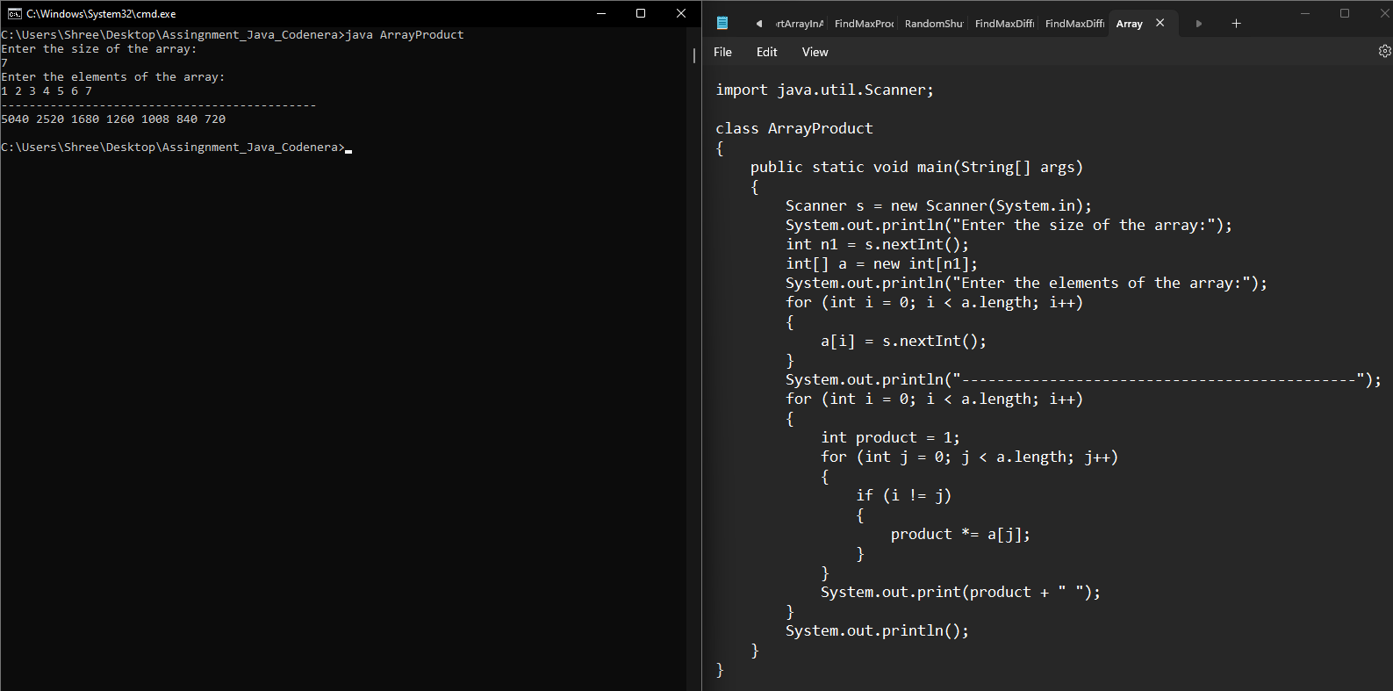

**5. Write a Java program to find maximum difference between two elements in a given array of integers such that smaller element appears before larger element.**

**Example:**

**Input :**

**nums = { 2, 3, 1, 7, 9, 5, 11, 3, 5 }**

**Output:**

**The maximum difference between two elements of the said array elements**

**10**

